NEEMA SCHOOL KENYA TRUST
22, LEONARD STREET SUTTON ST HELENS WA9 3HY
01744 810833 trimbyz@hotmail.co.uk

NEWSLETTER DECEMBER 2020
Dear Supporters,
Well , what a year we have had with Covid 19 and Donald Trump /USA election. We hope and pray that none of you have been badly affected by the pandemic and all stay safe and well. Hopefully there is light at the end of the tunnel and 2021 will be a better year.
We started the year in January with 340 children attending and an additional teacher, making 9 teachers employed.
Our school had to close in March along with all other schools, colleges and universities in Kenya. The children have missed nearly a full year of education with only the class of the oldest children returning to school in October, keeping to social distancing, wearing masks and washing hands. We have had to supply extra water tanks -- one at the gate so everyone visiting the school can wash their hands before they get to the buildings, and various washing points round the school grounds along with sanitizer hand wash and a number of thermometers -- gun type - to check the temperatures of all visitors, pupils and staff every day.

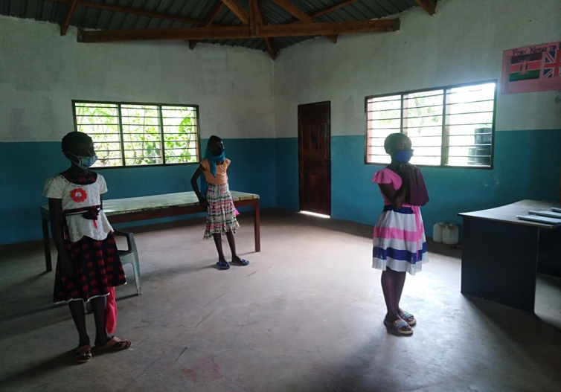
Social Distancing Water tank for hand washing at the gate.
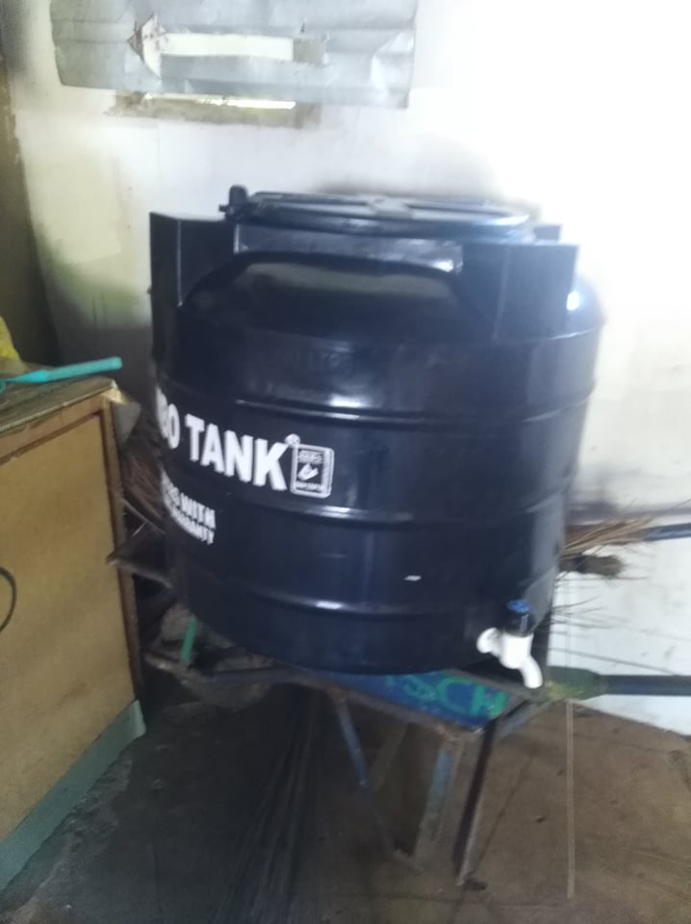
The parents were worried about the older children having nothing to do for so long and risking getting involved in drugs or unwanted pregnancies so they asked the Board of Governors if the teachers could give them homework to do each week. It was arranged for them to come to the school one day a week and collect their work and return it the following week.
Since Dr Richard Fitton returned home from his visit to the school he has been doing fantastic work in spreading the word about how wonderful the charity is and has managed to raise extra funds for us . We have had an incredible donation which will cover the costs of building two new classrooms.
One thing Richard really appreciated was the great atmosphere and strong bond between the staff members and we are pleased to say we have managed to pay all the staff throughout the lockdown in Kenya so making sure they did not suffer financially and they will all stay together when the school eventually reopens. Thank you to all who contribute on a monthly/ regular basis and make this possible.
Our lady teachers
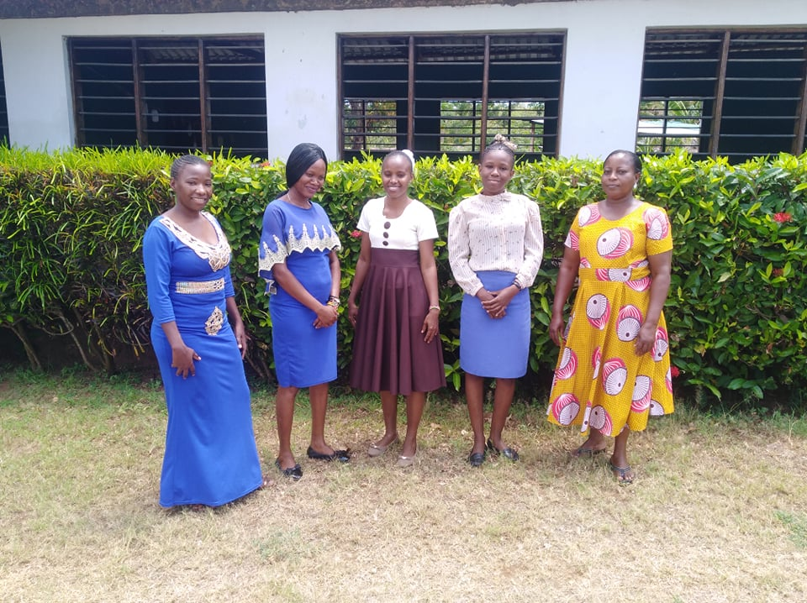
The gardeners have looked after the school throughout the lockdown and kept the garden and buildings well maintained. We have had to have repairs to the plumbing in the toilets and to the water pump ( again !) and have replaced old window coverings with new metal mesh blinds. It looks much better as well as being more secure.
Our male teachers.
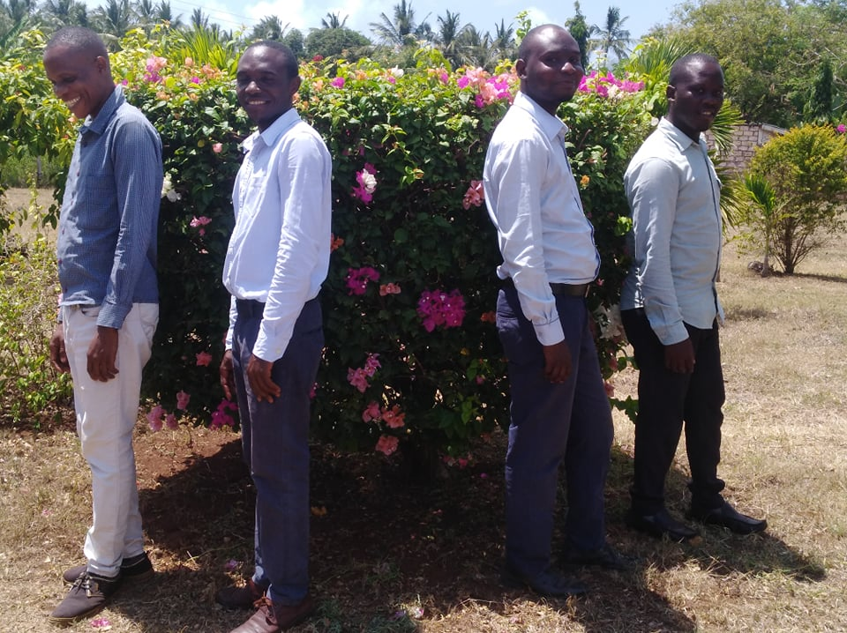
We are waiting for the School Inspectors to come to check all Covid prevention measures have been done according to Government orders.
The Head Teacher has organised training sessions with the parents to teach them the need for keeping to the Covid rules at home to help safe guard the children. These meetings were well attended by parents and show the interest the parents have in the school and the support they give to the staff.
We have been saddened by the loss, through Covid 19, of one of our friends and supporters in Kenya --- The Right Honourable Mustafa Idi, the former MP for Kilifi North. We send condolences to all his family and friends.
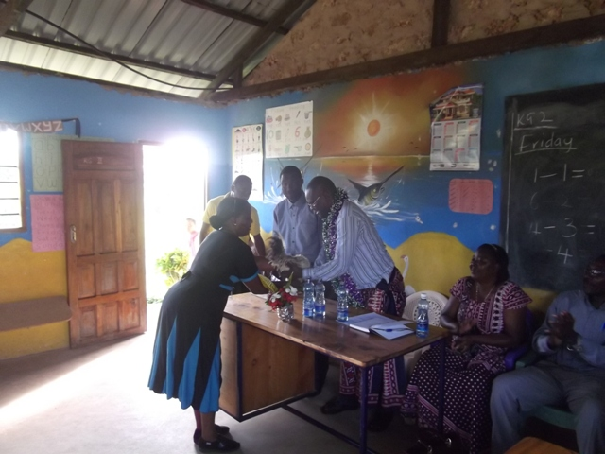
A visit to the school by the Hon. Mustafa Idi and presentation of a chicken to him to welcome him.
We would like to thank all our friends and supporters of the school for the continued faith in us and our project.
Thank you to the generous friends on Facebook that sent donations to buy the needed items to comply with the covid 19 rules set down by the Kenyan Govt to allow the school to open.
We are so happy to see the progress at the school ,not only of the lovely children but of our fantastic team of teachers, managers, Board of Governors, gardeners, cooks and maintenance staff .
Geoff and I miss going over there and being able to meet up with them all.

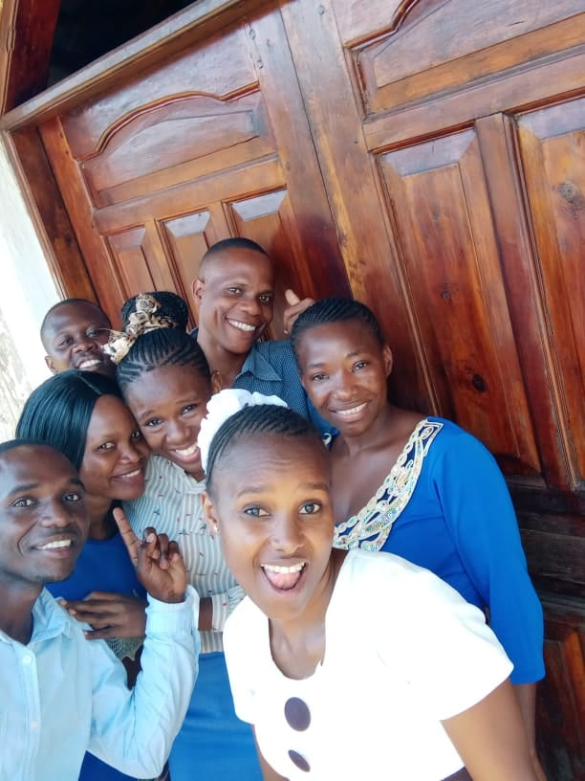
We wish you all a Very Happy Christmas and all the best for 2021.

