NEWSLETTER JUNE 2015

We are pleased to say that wonderful progress has again been made with the fund raising and building works in Kikambala, Mombasa.
The fourth classroom opened in January 2015 to the delight of the older children who are pleased to move into a new classroom each year !!
We now have 166 little children from the poorest backgrounds in free education ,enjoying themselves learning and having great playtimes with the teachers. We had a good intake in January and had forty 3/4year old children start. We also had a new teacher join us- -a young man called Patric - who Geoff and I met a few years ago. He impressed us so much that we told him if he had teaching qualifications by the time classroom 4 was built then he could be the teacher. Margaret, our Head teacher, met him at college and he had an interview with the Board of Governors and was appointed.
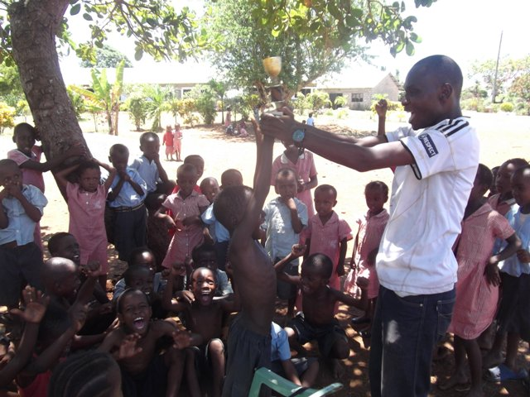
He has become a very good addition to our teaching team. He organised an end of term football match and someone has given a trophy to play for. Here is Patric presenting the trophy to the captain of the winning team.
We now have to find another £65 per month to pay Patric so if anyone can donate giving a few pounds each month that would really be very helpful.
In January Geoff and I held a Birthday Party for ourselves and asked for donations to the Charity instead of any presents. We had a lot of our friends came and raised over £200. Many thanks to all who donated and came to share our day.
We held another Fashion Show at Longdendale High school in Hollingworth in March 2015 which was a great success and raised nearly £500. A lot of bargains were bought by the audience who enjoyed the evening.
David Jones, Editor, wrote an article in the Glossop Chronicle newspaper about the Fashion Show. A lady in the Stockport area read the article and rang us to chat about the charity. A few days letter the charity received a large donation from the lady and her friends which we are very grateful for. This money is helping to complete the building of the fifth classroom in time for opening in January 2016.
The building is going well - -our builder Rofus and his team are so good and trustworthy and take great pride in their work . It is really refreshing to see the care they take to get things right. We have watched them while in Kenya , thinking if we had been doing that we would have thrown the trowel over the fence but they are so patient !!
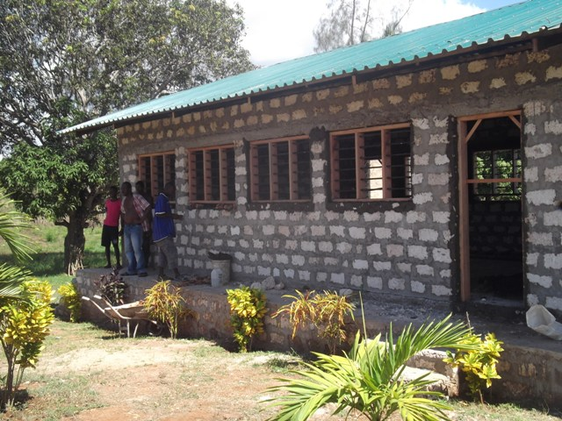Classroom 5 in progress.
The children are now getting a meal a day but this is something the parents are doing as we still do not have sufficient money coming in each month to be able to pay for the food. Some of the parents are buying the food and cooking it and the children have to pay 30 ksh, about 23p for their meal, usually beans and rice. We have set up a fund so that if a child's parent cannot afford the 30 ksh then the teacher can use money from the fund to pay for the food so the child will get their meal. Eventually we hope to be able to take over the buying of the food so the parents do not have this expense. It is so difficult for them to find any amount of money when they earn nothing.
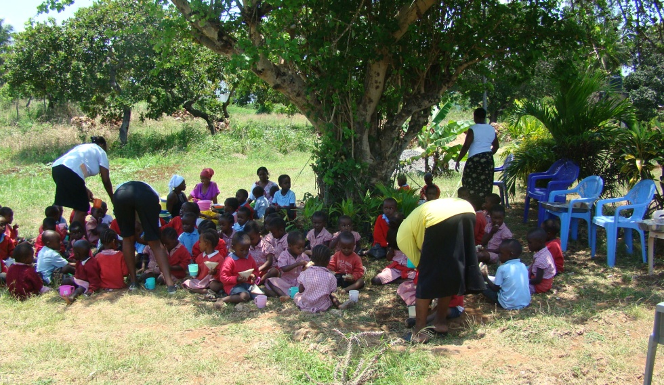Lunch time

Would anyone like to do a sponsored parachute jump ?
We are now registered with a company who arranges these for charities. Please contact us for details.
Is anyone doing a run ( eg half marathon ) or a bike ride and would like to raise money for us by getting sponsorship from family, friends , work mates. We can supply sponsor forms and Neema T shirts. Please ask for details.
Do any of you have any other ideas for fund raising that you would like to do for us ? We would welcome suggestions.
We can visit any groups you are a member of eg Rotary Club , Women's Institutes, Mothers Union, school parents /governors etc to give a talk about how and why we set up the charity , food in Kenya or the education in Kenya.

At the end of term the teachers arranged a meal and Patric his football match for all the children to have a good time before going for holiday. The football match was between the children in KG 4 and a team from KG 3. The KG 4 team won. The lady teachers cooked the meal and served it to the children. We may have to give some hygiene lessons when we go next time as the food was served with the bowls on the floor !
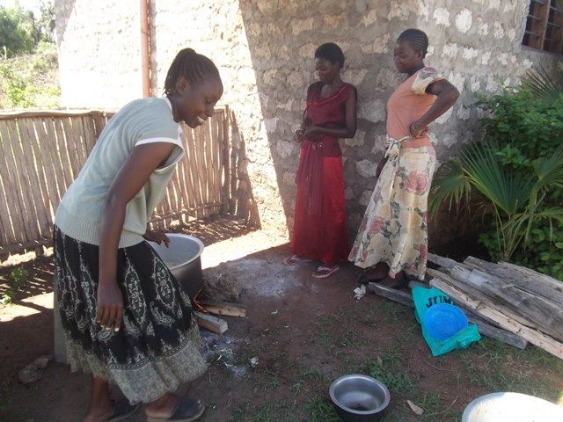 Preparing the meal.
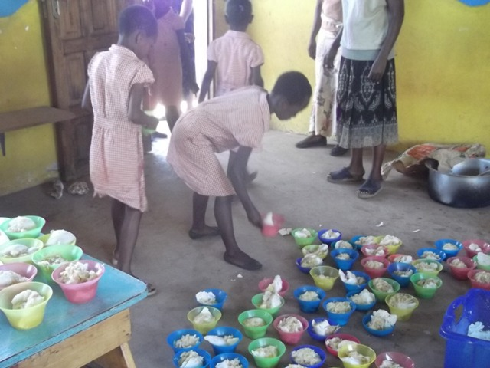Collection the meal.

We have had a laptop computer donated for us to take with us in September . We thank the donor for this wonderful gift. We hope to be able to start basic computer lessons next year with the older pupils.
The rain season, March to May, brought the usual problems of flooding and mosquito's and damage to crops bringing illness and hunger to the villagers. Our gardener, Paul and Manager, Victor have both been ill with flu or Malaria. Victor is prone to Malaria but both managed to buy medication due to earning wages and are now on the road to recovery.
We will be visiting the school in September this year and if anyone would like to come with us for an adventure you won't forget, please let us know and we will help you with the details. The hotel we stay at -- the North Coast - will give a 15% discount to any friends we bring. We can promise you the best welcome there that you will ever receive from anywhere in the world !!
We are having a new Website built for us and would like to thank Paul for all his help and patience with me ! It is www.neemaschoolkenya.org.uk and hopefully will be completed soon when Paul has all the photos from me.
Thank you to all who have helped us in the last year and for your continued support for this worthwhile project. If you were to see the happiness of these lovely children you would realise what your kindness and help is achieving.
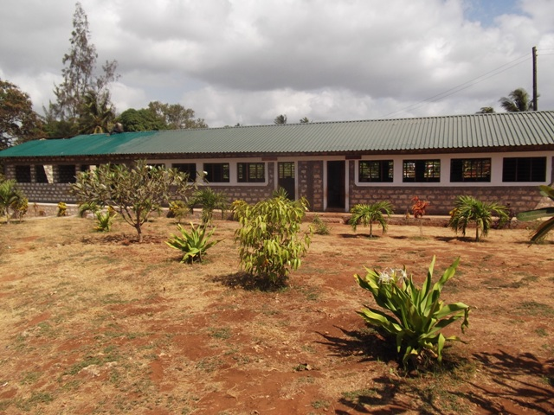

Please help us to help them.

